COMPUTER NETWORKS

ASSIGNMENT NO-1

Q 1)
Ans a) The output on running ifconfig on my device is as follows:-
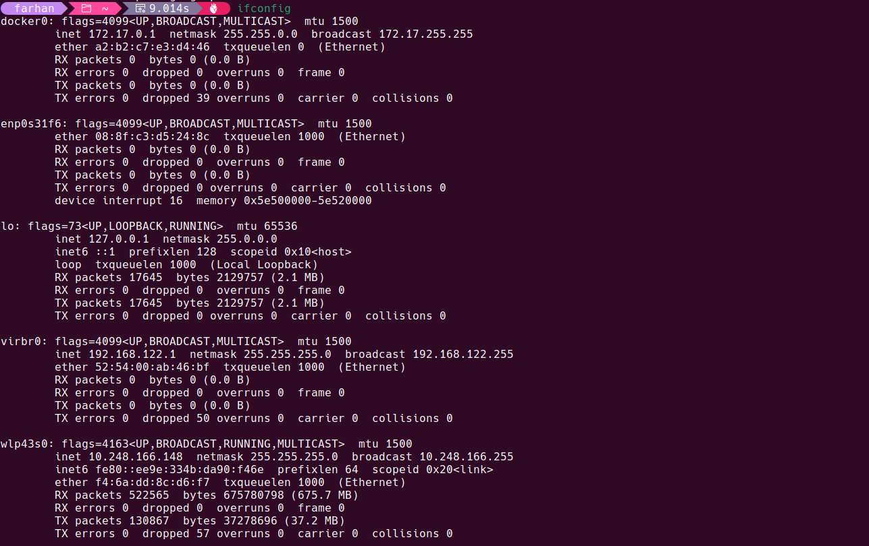
As seen the image the ifconfig command describes various network interfaces of the device such as wlp43s0 which is the WiFi network interface and on top of that it also gives us information about the activities of the network interfaces for example the no. of packets shared . As we can see my device has a wireless connection , Ethernet connection , a connection created by docker so as to connect the docker application to the internet. We can also see that except wlp43s0 no other interface is receiving any kind of data so we can say sat only wlp43s0 is active at the moment.

Ans b) Some of the options of ifconfig are as follows:-
1)txquelen – It is used to decide the queue length before processing it further and sending to the next routers it decides how many maximum packets can stay in the queue at a given point of time .
2)up and down- It is used to switch off/on a network manually as per the requirement .The commands used are as follows - sudo ifconfig wlp43s0 down,sudo ifconfig wlp43s0 up.
3)mtu-MTU stands for maximum transmission unit which describers the maximum size of a packet .It can help in stablizing a connection or improving it in case of high-latency scenarios.
4)-s – It stands for short list and summarises each network removing residual information from each of them . It gives output as shown below .
